- Inhibition of methanotrophs mediates high methane emissions from shallow coastal sediments

- Elias Broman, Xiaole Sun, Christian Stranne, Stefano Bonaglia, Marc Geibel, Alf Norkko, Christoph Humborg, Francisco J.A. Nascimento

Additional Information figures
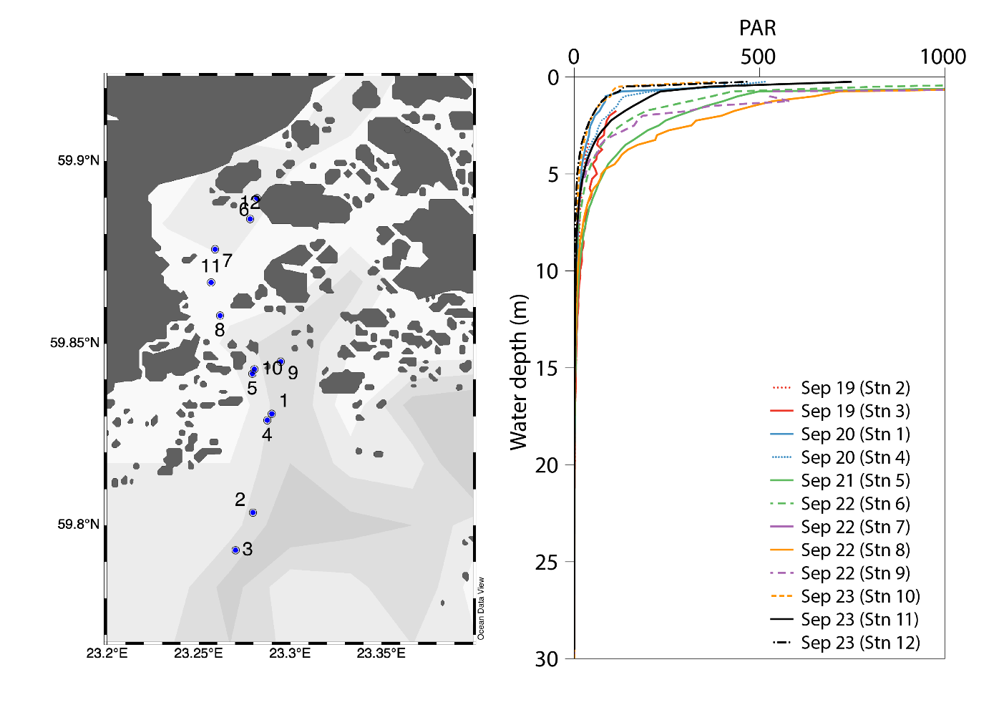
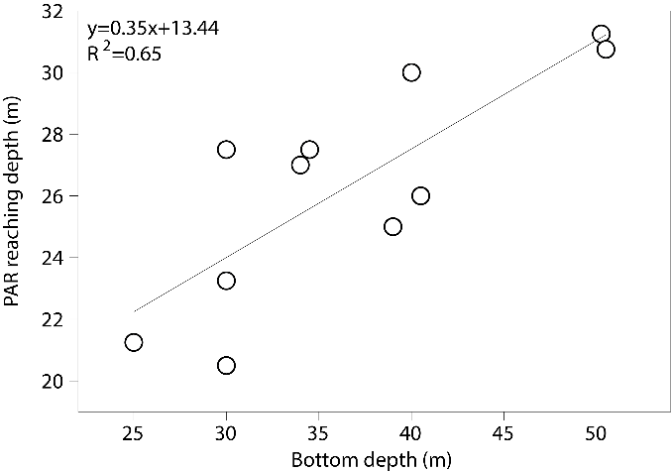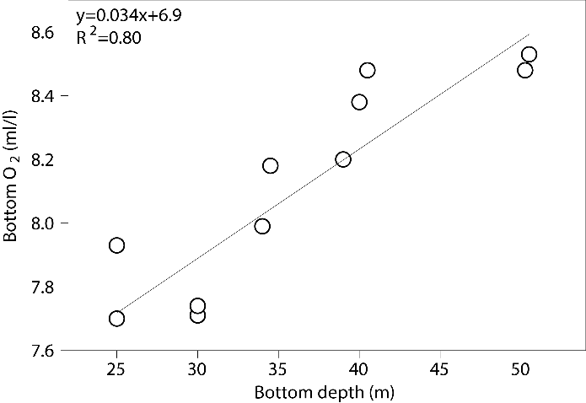
Figure S1 Top panel: CTD profiles from 12 locations inside the Storfjärden bay (note that CTD station numbers and not related to the station numbers were sediment was collected). PAR light profiles were collected during the 2018 sampling campaign between 19–23 September. Bottom left panel: Water depth vs the depth PAR is measured to be 0. Bottom right panel: Water depth vs oxygen concentrations in the bottom water. Station 5 is not shown in bottom panels as PAR never reached 0.
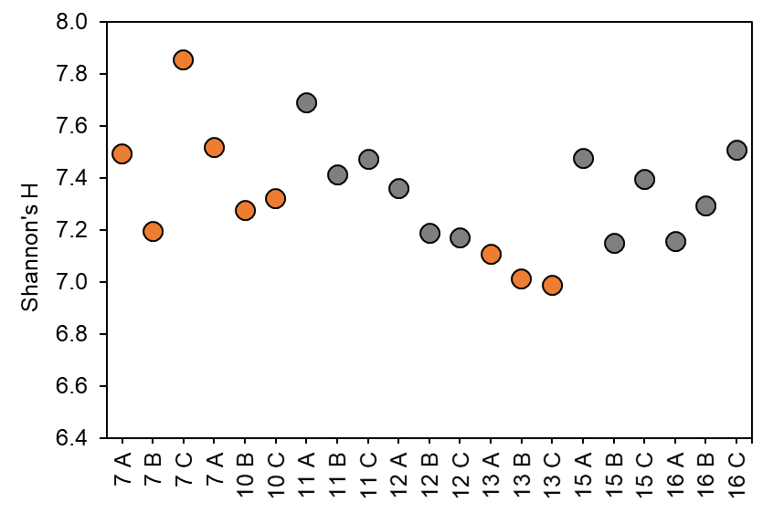
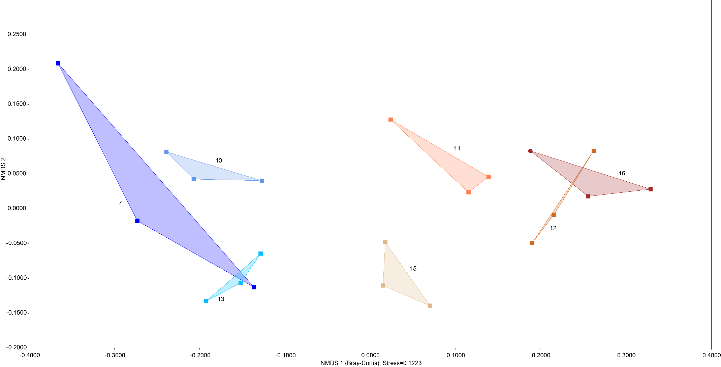
Figure S2 Top: Shannon’s alpha diversity (mean of bootstrap × 100). Inshore stations have been coloured orange. Bottom: NMDs showing the Bray-Curtis beta diversity of all samples (16S rRNA data). Station names are indicated next to their cluster of data points (n = 3 per station).

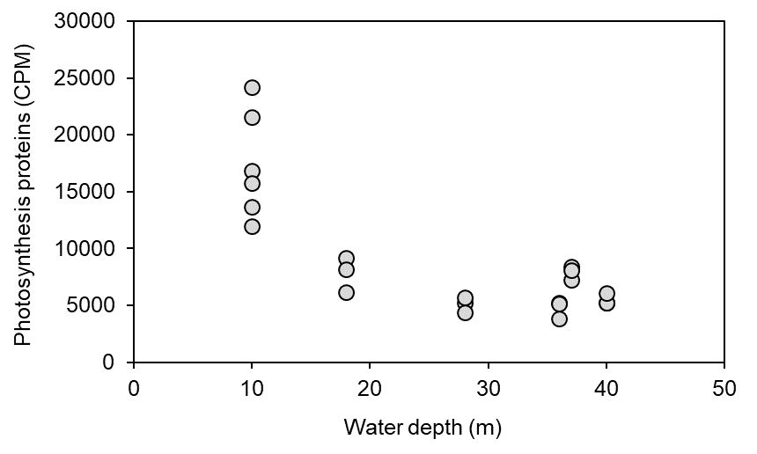
Figure S3 The graph shows RNA transcripts attributed to proteins in the GO category photosynthesis (y-axis, CPM-values). The x-axis shows the water depth (m) in the studied stations.

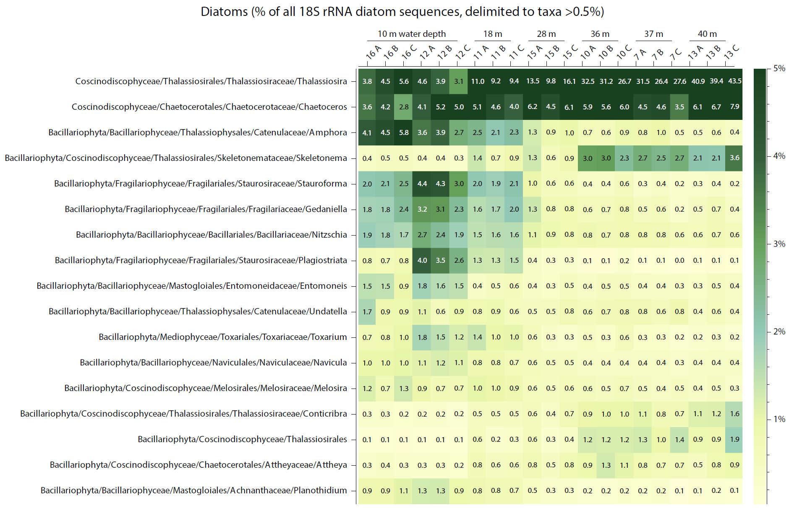

Figure S4 Relative abundance of 18S rRNA sequences belonging to diatoms. The colour gradient and numbers in the heatmap shows the % per taxa compared to the whole diatom community. The heatmap only shows taxa with a total average > 0.5%.

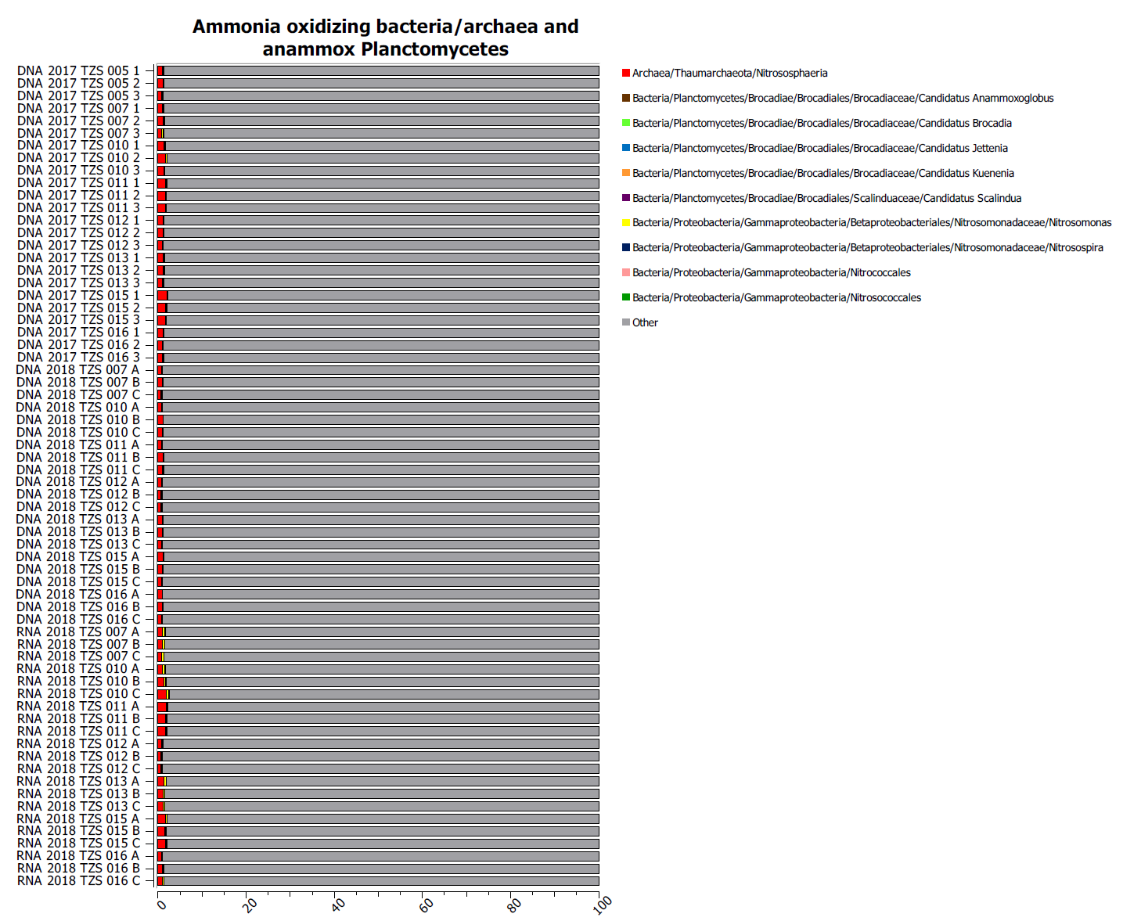
Figure S5 The relative abundance of ammonia oxidizing bacteria/archaea and anaerobic ammonia oxidizing (anammox) Planctomycetes taxonomic groups. The x-axis shows the relative abundance (%) of the whole microbial community.

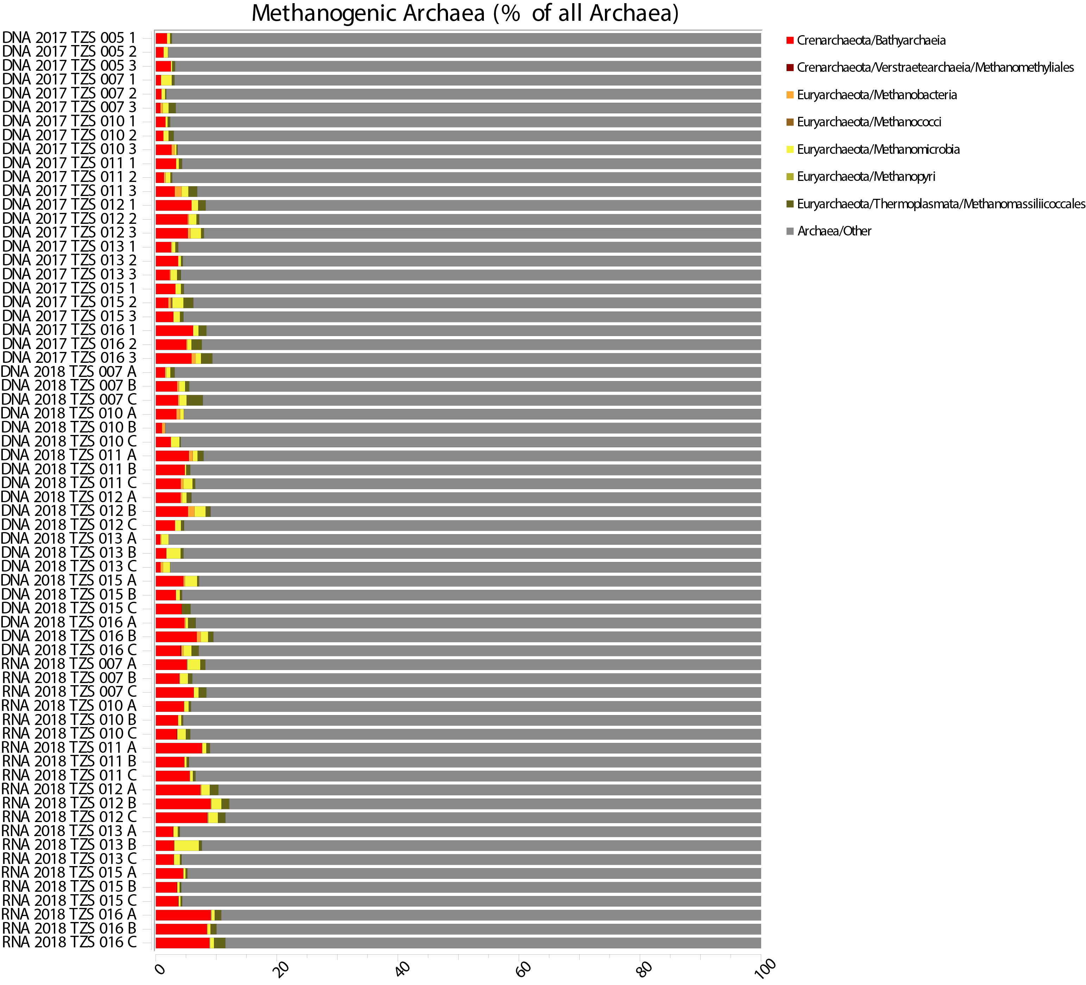
Figure S6 The relative abundance of methanogenic archaeal groups in the archaea dataset. The x-axis shows the relative abundance (%) of the archael community.

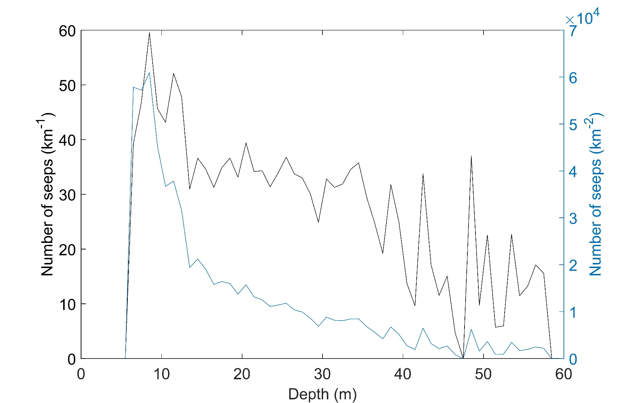
Figure S7 Depth plotted against number of seeps per km (left y-axis) and against number of seeps per km2 (right y-axis).

